Service for the Lord’s Day
October 11, 2026
*Please stand in body or in spirit, as you are able.
All are invited to say or sing together the liturgy printed in bold.
We Gather in God’s Name
Prelude Processional in C Hal Hopson
Welcome and Announcements
Minute for mission
Call to Worship
Leader: O come, let us sing to the Lord
All: and shout with joy to the rock of our salvation!
Leader: Let us come into God’s presence with thanksgiving,
All: singing joyful songs of praise.
Leader: Come, let us worship the Lord.

*Hymn #476 O Worship the King
Invitation to Confession
Corporate Prayer of Confession
Eternal God,
in whom we live and move and have our being,
whose face is hidden from us by our sins,
and whose mercy we forget in the blindness of our hearts:
Cleanse us from all our offenses,
and deliver us from proud thoughts and vain desires,
that with reverent and humble hearts
we may draw near to you,
confessing our faults,
confiding in your grace,
and finding in you our refuge and strength;
through Jesus Christ your Son.
Assurance of Pardon
Leader: The saying is sure and worthy of full acceptance, that Jesus Christ came into the world
to save sinners. I declare to you in the name of Jesus Christ, you are forgiven.
All: Thanks be to God.
*Gloria Patri
Glory be to the Father, and to the Son, and to the Holy Ghost;
As it was in the beginning, is now, and ever shall be, world without end. Amen, Amen.
*Sharing the Peace of Christ
We invite you to share the peace of Christ with those near you. Also at this time, we invite children ages 4 through 12 to go to the chapel with Brandy Webb for Worship Workshop.
We Hear God’s Word
Choral Prayer for Illumination
Spirit of the living God, fall afresh on me. Spirit of the living God, fall afresh on me.
Melt me. Mold me. Fill me. Use me. Spirit of the Living God, fall afresh on me.
Scripture Reading: Genesis 29:15-35
Sermon Thy will be done on earth as it is in heaven. Blaine Hill
* Hymn #366 Jesus, Thy Boundless Love to Me
We Respond to God’s Word
*Affirmation of Faith The Apostle’s Creed
Hymnal page 14
CALL TO OFFERING
Offertory He Watching Over Israel Felix Mendelssohn
*Doxology
Praise God from whom all blessings flow; Praise Him all creatures here below;
Praise Him above ye heavenly host; Praise Father, Son, and Holy Ghost; Amen.
*Prayer of Dedication
We Go Out in God’s Service
*Hymn #447 Lead on O King Eternal
Benediction
Postlude Rigaudon Andre Campra

Welcome to First Presbyterian Church of Lynchburg
We are glad to be worshipping together today!
If you are visiting with us, here are a few items you may find helpful.
Building Hospitality
Our building is a wonderful resource. It can also feel like a labyrinth when you are learning your way around. A few key locations may be helpful to you: Accessible Restrooms can be located down the main hallway from the Foyer. The Elevator is also located down the main hallway from the Foyer. The Nursery is located behind the chapel down the hallway to the right of the main entrance. In addition to these locations, there are additional supports available to worship participants: hearing-assist devices and large print hymnals, Bibles, and bulletins can be found in the narthex. Ushers are available and willing to assist you in finding your way or answering other questions. Wayfinding signs are posted at all intersections throughout the building.
Welcoming Children
Just as Jesus welcomes the little children to come, so we welcome children of all ages in worship. We believe we are better when all members of God’s family are included! So that the worship service can be as welcoming for our littlest ones as possible, we provide worship carts with a variety of resources to make a worship bag. All children are invited and encouraged to participate in worship with their families. We consider it a joy to have your children and all the wiggles, giggles, questions, noises, and insights they bring.
Interested in joining?
If you’d like to be here in a more official capacity, you are invited to join First Presbyterian as a member. Everyone who is part of our community is treated the same. Joining isn’t about special treatment, but rather about a commitment you make to following Jesus alongside others trying to do the same. New member gatherings take place throughout the year based on interest. If you are interested in learning more, please contact Alex Collier (alex@fpcly.org).
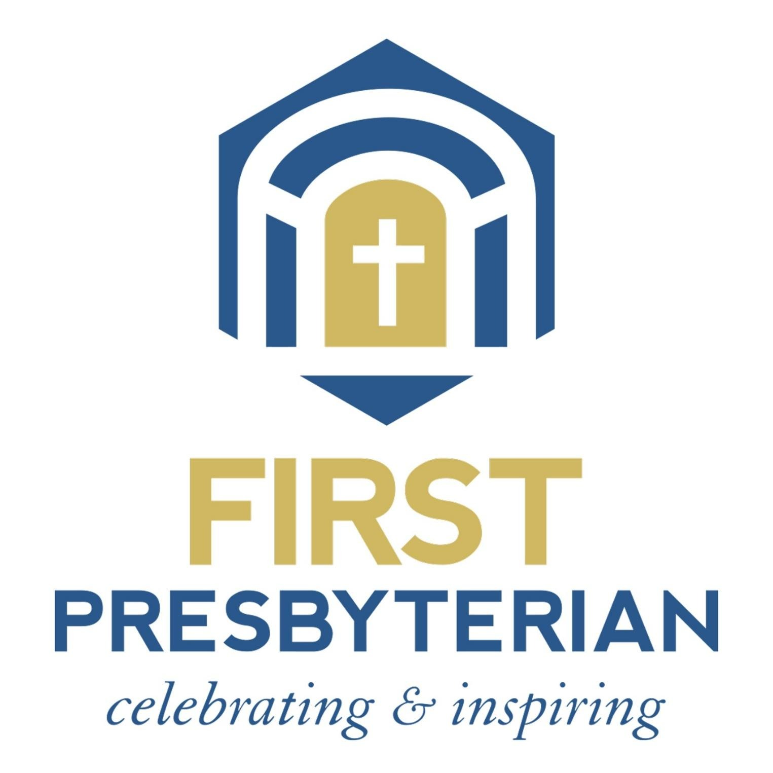
October 11, 2026
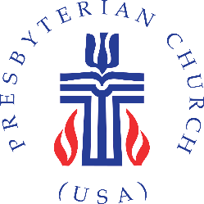

1215 Virginia Episcopal School Road, Lynchburg, VA 24503
(434) 384-6231 · www.fpcly.org · e-mail: info@fpcly.org
https://www.facebook.com/firstpresoflynchburg/

